International Baccalaureate


Mathematical Studies SL
GDC Teacher Support Material

− Booklet No. 2 −



Using the
TI – 84 Plus
for SLMS

United Nations International School

July 2008

Table of Contents

Using the GDC in Math Studies . . . . . . . . . . . . . . . . . . . . . . . . . . . . . page 2

Some Relevant Features of the GDC . . . . . . . . . . . . . . . . . . . . . . . . . pages 3 – 7

Five Examples for All Students to Consider:

1. Using PolySmlt to Solve a Polynomial Equation . . . . . . . . page 8

2. Solving a System of Equations by Graphing . . . . . . . . . . . . pages 9 – 10

3. Using PolySmlt to Solve a System of Equations . . . . . . . . page 11

4. Using the GDC to Show Working Out for
Linear Regression Analysis . . . . . . . . . . . . . . . . . . . . . pages 12 – 14

5. Performing a Chi-Squared Test for Independence . . . . . . . . pages 15 – 16

Using the Graphic Calculator in Mathematical Studies

An understanding and use of the graphic display calculator is now required of all students in Standard Level Mathematical Studies. Full advantage of the GDC may be taken by students for general course work, for completion of project work and for examinations.

It is recommended that a school philosophy of GDC use clearly explain why this technology is required. A statement similar to the following could be included:

Using a GDC to "get an answer" is not a substitute for true mathematical understanding. Students are therefore expected to develop an understanding of all concepts and theory behind GDC problem solving. This includes appropriate problem interpretation, information set up and solution analysis.

Students in Math Studies may lack confidence in using the GDC, and the key role of the teacher may be to help students develop a more confident approach to its use. It is important to go slowly, and build confidence in GCD use.

Getting Help

A central point of help for IB calculator use is to be found on the OCC . Go to the OCC page for Mathematical Studies SL. Click on the link for "General Documents" and look for the "Teacher's support material, graphic display calculators" link. Note that these notes are provided for all levels of IB Mathematics. Hence, students will have to be carefully directed to the relevant sections.

Some Math Studies User Issues

- Errors in calculations or graphical representations are made by students because of inappropriate MODE or WINDOW settings.

- Graphic Calculator notation and symbols are used in examination solutions, and this is a "no-no".

- Students do not provide adequate detail describing GDC methods on examinations and, hence, appropriate method marks cannot be awarded.

- Students provide GDC work on projects through connection software
(e.g. TI Connect) and do not provide appropriate labels and explanation.

- The transfer of graphs, diagrams or information from the GDC to the paper is often not clear.

- Final calculation solutions are often provided to an inappropriate accuracy.

Some Relevant Features of the TI 84+

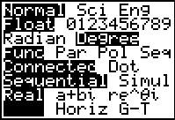
MODE - make sure that appropriate mode settings are used

  - Degree – the GDC reverts to Radian mode when it is reset.
  - Full- the full screen is used for any graph display. Students may find it helpful to use the G-T function. The screen then splits and gives both the graph and the table of values.

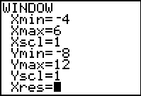
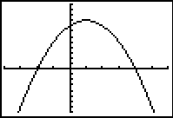
Y = , WINDOW and GRAPH − these three functions are to be used by all students on course work, project work and examinations at any and all times.
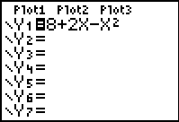

TABLE (second function of GRAPH) and TBLSET (second function of WINDOW) – frequently used to read and interpret functions.
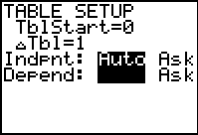

continued on next page . . .

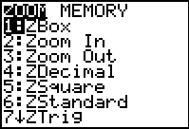
ZOOM – students should be shown how to reset to default Zstandard, etc. . .

- 4: Zdecimal – this setting will assign one decimal place to each pixel, a great help when using Trace
- 6: Zstandard – provides standard settings, but note that the resulting graph is a distortion.
- 7: Ztrig – helpful for graphing trigonometric functions, but make sure mode settings are set for degrees.

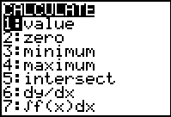
CALC – one of the most frequently used calculator functions.

- 1: Value − determines y-value of a given function for any defined
x-value
- 2: Zero − calculates x intercepts
- 3: Minimum − finds the co-ordinates of relative minimum point of a given function over defined interval
- 4: Maximum − finds the co-ordinates of relative maximum points of a given function over a defined interval
- 5: Intersect − determines the co-ordinates of points of intersection between any given functions
- 6: dy/dx − finds the value of the gradient of the curve at any given point

continued on next page . . .

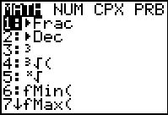
MATH – obviously can be used for a number of calculations.

- 1: Frac − will convert a decimal to fraction in lowest terms.
- 8: nDeriv − provides the value of the derivative of a function at a particular point: nDeriv(expression, variable, value)
- 0: Solver − can be used to solve most equations met by Studies students.

STAT – this is extremely useful and is required at one time or another on all exams.

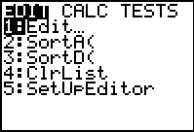
- EDIT − students input and arrange data through this function

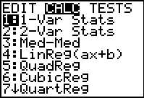
- CALC − students will frequently use 1-Var Stats and 2-Var Stats. This function also provides powerful modeling possibilities (e.g. LinReg (ax+b))

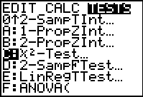
- TESTS − will be required for the chi-squared tests for independence.
DRAW (second function on the PRGM key) – the function 5: Tangent( is useful for calculating and drawing the equation of a line tangent to a given function.
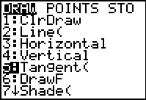

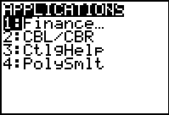
APPS: Flash Applications: – some flash applications are allowed on examinations including FINANCE, POLYSMLT and CATALOG HELP.

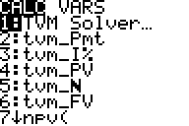
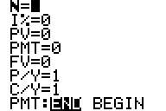
FINANCE – 1: TVM Solver should be used with care. Some questions may require its use, but it will require a fair amount of practice to master.
- N – total number of payment periods
- I% – annual interest rate
- PV – the present value, enter as a negative to represent cash flow
- PMT – the payment amount (0 when solving compound interest questions)
- FV – the future value
- P/Y – the number of payment periods per year
- C/Y – the number of compound periods per year

continued on next page . . .

PolySmlt – this flash application may have to be downloaded from the TI website (education.ti.com ). It can solve any polynomial equation and any system of equations. This is very useful for students in Mathematical Studies.

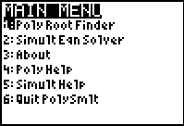

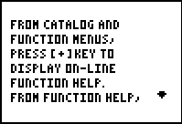
Catalog Help – another flash application that is allowed on exams. It can help one to remember arguments from calculator functions when one's brain goes missing. This may not be a standard flash app on some calculators, but it may be downloaded from the TI website for free.

Five Examples for All SLMS Students to Consider

All students must be able to use basic GDC functions. This includes basic calculation and basic use of graphing and statistical functions. In addition to those basics, a few other calculator techniques are useful.

1. Using PolySmlt to solve a polynomial equation:

Example: Solve the equation 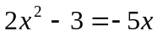

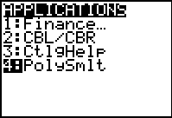
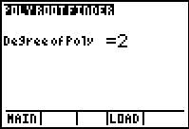
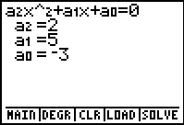
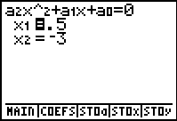
Solution: First simplify the equation to 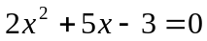
Step 1: From the APPS key
enter PolySmlt
Step 2: From PolySmlt
enter
Poly Root Finder
Step 3: Enter the degree of the polynomial,
in this case 2.
Step 4: Enter the coefficients of the 2nd degree polynomial.
Step 5: Press the GRAPH key (it corresponds to SOLVE)

2. Solving a system of equations by graphing

Example: Solve the following system using a graphic calculator:

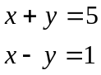

Solution: First each equation must be converted to slope-intercept form:

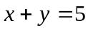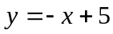
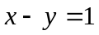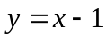
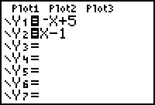
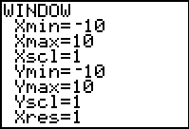
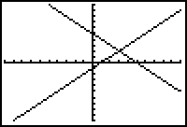
Step 1: Enter each equation in your calculator using Y = and graph using a Zstandard setting.
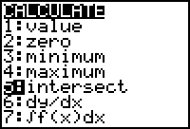
Step 2: Enter 2nd and CALC. A menu will appear like the one shown below.

continued on next page . . .

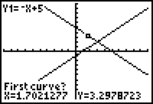
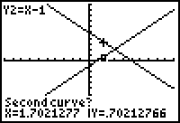
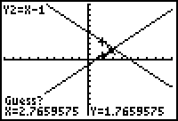
First curve?
Second curve?
Guess?
Step 3: Use 5: intersect. You will then have to reply to a series of three questions. Press ENTER to acknowledge each curve. Adjust your cursor for the guess and press ENTER.

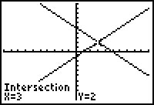
Solution :

x = 3 and y = 2
The solution for the system will then be shown:

continued on next page . . .

3. Using PolySmlt to solve a system of equations:

Example: Solve the system: 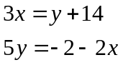

Solution: First write each equation in the form 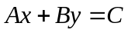, where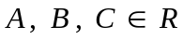.

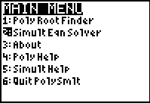
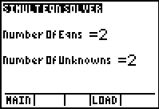
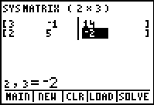
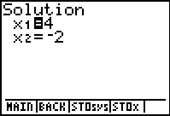
Thus, 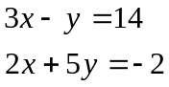
Step 1: From the APPS key
enter PolySmlt
Step 2: From PolySmlt
enter
SmultEqnSolver
Step 3: Enter the number of equations (2) and the number of variables (2).
Step 4: Enter all coefficients and constants of the system in an augmented matrix
Step 5: Press the GRAPH key (it corresponds to SOLVE)

4. Using the GDC to show working out for a linear regression analysis

Example: Independent variables, x and y are shown for five students are shown in the table below.

 | Student | A | B | C | D | E
 | x | 2 | 3 | 5 | 6 | 8
 | y | 3 | 4 | 5 | 8 | 8

Solution: To calculate the correlation coefficient and regression equation we would normally show calculations in a table like the one shown below:

x y x² y² x y

2 3 4 9 6
3 4 9 16 12
5 5 25 25 25
6 8 36 84 48
8 8 64 64 64

Totals 24 28 138 178 155

Note that these can be obtained by using the STAT function of the GDC.
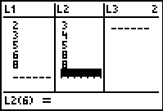
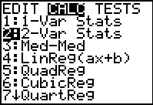
Step 1: Enter STAT. Under the EDIT menu heading enter 1: Edit. Enter all x values in List 1 and all y values in List 2.
Step 2: Go back to the STAT function key and move to the CALC menu heading.
Enter 2: 2-Var Stats and press ENTER Again.

continued on next page . . .

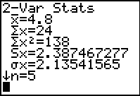
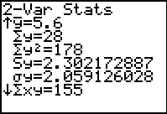
Step 3: The display now shows all necessary calculations required. Note that you will have to scroll down to read all calculations.

It is now possible to show appropriate calculations for necessary working out.
Now: 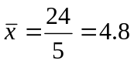 and 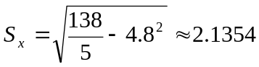

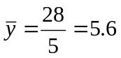 and 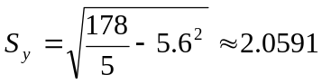

and furthermore, 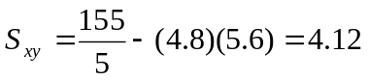

BEWARE: notation differs between the standard deviation on the GDC (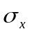) and the official IB notation (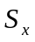)!

Thus we can now calculate the value of :

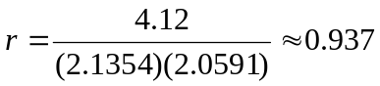 (3 sig. fig.)

And the regression equation can be found using:

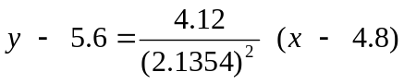

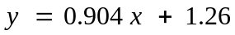

continued on next page . . .

This result can be verified on the GDC as follows:
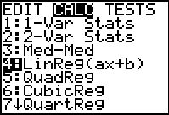
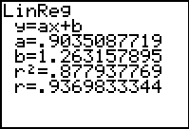
Step 4: Go back to the STAT function key and move to the CALC menu heading. Enter
4: LinReg (ax+b) and press ENTER Again.

Step 5: The display now shows the necessary results. Note to display the correlation coefficient , the GDC Diagnostic On must be engaged.

Note: When using 2-Var Stats or LinREG (ax+b) the CALC menu, the calculator will automatically use List 1 for x values
and List 2 for y values. If data is entered in any other lists, then those lists must be noted as commands are given. See example below for calculating 2-Var Stats for data entered in
Lists 3 and 4.
L₃ and L₄ must be entered after 2-Var Stats with a comma separating the two.
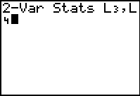

continued on next page . . .

5. Performing a chi-squared test for independence

Example: The contingency table below shows observed data of a poll concerning voter preference vs. gender.
Political Party

 | Republican | Democrat
Male  Gender | 116 | 94
Female | 92 | 98

Determine whether voting preference is independent of gender.

Solution: To perform the 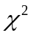 test on the GDC we must first enter this data.

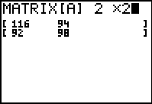
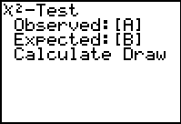
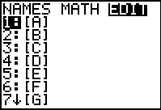
Step 1: Enter 2nd and MATRIX. Move to the menu heading EDIT. Press Enter.
Step 2: Change matrix dimension to 2 x 2 and enter all values in the appropriate places.
Step 3: Go back to STAT. Move to the TESTS menu heading and
enter C:
− Test
Step 4: Press ENTER to begin the test and a display like the one shown below will appear.

continued on next page . . .

The GDC is now ready to perform the statistical test. The test can be run in two ways.
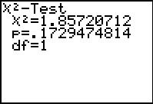
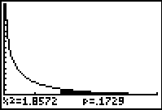
Step 5: Move the cursor to Calculate and press ENTER. The following display will be shown.
Step 5: Move the cursor to Draw and press ENTER. The following display will be shown.
OR

Now if you proceed to the MATRIX function of your calculator and go to EDIT and scroll down to 2: [B] , you will find that [B] now contains a calculated set of expected frequencies. See displays shown below.

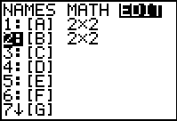
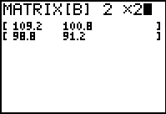

Note that both of the GDC methods shown calculate values. The meaning of this value is best seen on the graph of the chi-squared distribution for degrees of freedom = 1.

The value of = 0.1729 or 17.29% represents the fractional part of the area under the curve and to the right of the calculated value of 1.8572.

This calculated value can now be directly compared to the level of significance of the test. In our original example, the level of significance
is 1%.

The rule of comparison is simple . . . if the value is Bigger than 0.01 (level of significance) then Accept . Remember BA, the member of the A-Team?

